LEAD JOURNEY ROADMAP
The Best LEADERS are the Best LEARNERS
NAME:
LIFO STYLE:
 | Where am I now on my journey from manager to leader? |  |  |  | What attributes of a learning mindset do I possess/ Will I need to develop? | 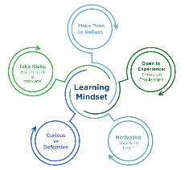
 | My transformational shift statement (Where do I want to be? What is my strategic leadership vision?)
 | What strengths will move me toward my leadership vision? |  |  |  | What gaps may I need to address to achieve my leadership vision?
 | Plan: What actions will I take to move me in the right direction? Who can help me?
 | - [What / Who]
 | - [What / Who]
 | - [What / Who]
 | How can my Matrix Mentor Team hold me accountable?

